

**Applied Science Private University**

**Faculty of Information Technology**

**Graduation Project Report**

ALONE IN THE DARKNESS

**Prepared by:**

Mohammad abu jalboush 202010595

Omar Ali 201910336

Saif Ibrahim 202120782

Ahmad Darwish 202010102

Diaa Abu Aisha 201910660

**Supervised by:**

Dr. Ayham Alomari

**June 2024**

**Copyright © 2023-2024 Applied Science Private University. All rights are reserved**

We certify that the work and ideas presented in this project is our own unless referenced.

Name and Signature:…seif ibrahim…………………………. Date:26/5/2024…………………

Name and Signature:…omar ali……………… ……………. Date: …26/5/2024………………

Name and Signature:…mohammad abu jalboush……… …. Date: …26/5/2024………………

Name and Signature:…ahmed darwish………… …………. Date: ………26/5/2024…………

Name and Signature:…diaa abu aisha………………… ……. Date: ………26/5/2024…………

**Contents**

List of Figures iii

List of Tables iv

List of Symbols v

Abstract vi

Chapter 1: Introduction 7

1.1 Description of the current situation and opportunity 7

1.2 Related work 7

1.3 Problem statement (limitation of current systems) 7

1.4 Problem solution 7

1.5 Project objectives 7

1.6 Technology and tools used 7

1.7 Project Plan (Gantt chart & PERT chart) 7

Chapter 2: Requirements and Analysis 8

2.1 Software Process Model with explanation 8

2.2 System scope with explanation 8

2.3 Functional Requirements & Non-Functional Requirements 8

2.4 Use Case Diagram with Use Cases descriptions 8

2.5 Activity Diagram for some use case scanrios 8

Chapter 3: Design 9

3.1 Sequence Diagrams for some use case scenarios 9

3.2 Detailed Class Diagram 9

3.3 Database ER Diagram (if applicable) 9

Chapter 4: System Implementation 10

4.1 Main System Screenshots 10

4.2 Important code fragments 10

4.3 List of Non-Implemented requirements and reasons 10

Chapter 5: System Evaluation 11

5.1 System Testing (some test cases) 11

5.2 System Evaluation 11

Chapter 6: Conclusion & Future Work 12

6.1 Conclusion 12

6.2 Future work 12

References 13

Appendix 14

# List of Figures

Figure 1: Use-Case Diagram **.**

# List of Tables

Table 1: Code conversion table 7

# List of Symbols

|  |  |
| --- | --- |
| **Symbols** | **Meaning** |
|  |  |
|  |  |

# Abstract

*Within the realm of interactive gaming, the fusion of cerebral challenges with time-sensitive dynamics has emerged as a focal point in fostering cognitive development. This report delves into the innovative landscape of 'Alone in the Darkness,' a puzzle-based gaming endeavor designed to immerse players in an environment that intricately merges intricate problem-solving with heightened time constraints. Conventional gaming paradigms often overlook the vital integration of time-sensitive challenges, neglecting the opportunity to nurture quick-thinking and decision-making skills in users. Building upon this identified gap, 'Alone in the Darkness' ventures to pioneer a transformative experience, cultivating players' cognitive faculties within an adrenaline-inducing framework. Embracing the paradigm of intellectual challenges enmeshed with temporal urgency, 'Alone in the Darkness' aspires to transcend the conventional gaming milieu. This project represents a culmination of meticulous game design principles, fostering an environment where users navigate intricate puzzles under the weight of imminent time constraints. Through the amalgamation of captivating storytelling, visually immersive elements, and the seamless integration of time pressure, this gaming innovation seeks to cultivate a realm where players not only confront cognitive hurdles but also refine their capacity for astute decision-making within the crucible of urgency. 'Alone in the Darkness' emerges as a pioneering educational tool, blurring the lines between entertainment and cognitive development in an unprecedented fusion.*

# Chapter 1: Introduction

In the realm of gaming, the fusion of puzzles and time-sensitive challenges often misses the mark in delivering an engaging experience that sharpens problem-solving skills under pressure. Traditional games tend to prioritize entertainment over the active development of critical thinking abilities, leaving a gap in the market for experiences that effectively combine excitement with intellectual growth. "Alone in the Darkness" steps into this void as an innovative gaming solution. It offers a fresh approach by immersing players in a world where solving complex puzzles becomes a thrilling race against time. Unlike conventional games, this project aims to create an engaging environment that not only entertains but also sharpens mental agility. Through this report, we delve into the development of "Alone in the Darkness," a game designed to challenge players' cognitive abilities within a suspenseful narrative. By seamlessly blending a sense of urgency with progressively difficult puzzles, this game endeavors to provide an experience that enhances problem-solving skills while keeping players on the edge of their seats. The primary focus lies in crafting a gaming experience that not only captivates but also cultivates essential cognitive skills. This introductory section sets the stage for a deeper exploration into the project's objectives, scope, and innovative approach taken to fill the gap in the gaming market for experiences that simultaneously entertain and empower players' mental faculties.

## Description of the current situation and opportunity

The current landscape in entertainment and gaming often caters to passive consumption rather than actively engaging individuals in immersive, intellectually stimulating experiences. There exists a growing need for interactive platforms that not only entertain but also foster cognitive development and critical thinking skills.

The opportunity lies in addressing this gap by offering a gaming solution that challenges individuals to actively engage their problem-solving abilities within a time-constrained environment. "Alone in the Darkness" presents an opportunity to bridge entertainment with education, providing a platform where users can immerse themselves in an atmosphere of suspense while honing essential cognitive skills such as strategic thinking, decision-making under pressure, and effective problem-solving.

In a world where the ability to think quickly and adaptively solve problems is increasingly valued across various professions and daily life scenarios, the need for a game like "Alone in the Darkness" becomes more apparent. This opportunity allows for creating an innovative gaming experience that not only captivates its audience but also equips them with valuable skills that transcend the virtual realm, preparing them for real-world challenges that demand agility, critical thinking, and quick decision-making.

## Related work

In examining comparable games, a prevalent drawback often observed is the absence of a compelling blend between time-sensitive challenges and intellectual depth. Many existing puzzle-based games excel in offering intricate problem-solving experiences but fall short in incorporating an element of urgency or time pressure. While games like 'The Witness’ and 'Portal' boast captivating puzzles and thought-provoking challenges, they lack the time-constrained environment that intensifies decision-making under pressure.

This identified gap serves as a catalyst for 'Alone in the Darkness.' Unlike its predecessors, this game seeks to bridge this chasm by infusing an adrenaline-inducing timer element into the puzzle-solving dynamics. By integrating a sense of urgency with progressively complex challenges, 'Alone in the Darkness' aims to deliver an experience that not only stimulates critical thinking but also tests players' ability to make swift, calculated decisions in high-pressure scenarios.

Related Work Disadvantages and Proposed Solutions:

In examining similar games, prior studies have highlighted the lack of time constraints integrated into puzzle-solving dynamics [1]. These acclaimed titles excel in offering complex puzzles yet miss the crucial element of time pressure, impeding the development of quick-thinking skills vital for real-world scenarios [2]

Contrary to these limitations, 'Alone in the Darkness' aims to bridge this gap by amalgamating suspenseful puzzles with time constraints [3]. This innovative approach addresses the identified disadvantage by immersing players in an environment where intricate puzzles demand rapid problem-solving within specified time limits [4]. By integrating the element of time, 'Alone in the Darkness' aims to enhance players' ability to make swift and informed decisions under pressure, effectively addressing the shortfall observed in existing games [5].

The absence of time-constrained puzzles in existing games represents a niche that 'Alone in the Darkness' endeavors to fill. This game's unique proposition lies in its ability to immerse players in an environment where solving puzzles not only stimulates the mind but also thrills the senses by challenging them to think swiftly and strategically within defined time constraints.

While these comparable games excel in various aspects of puzzle-solving, "Alone in the Darkness" takes a distinctive approach by merging time-sensitive challenges with a suspenseful backdrop, offering a distinct and engaging gameplay experience that targets the enhancement of rapid decision-making and problem-solving skills in a gripping, high-stakes setting.

Carrion is a [horror video game](https://en.wikipedia.org/wiki/Horror_video_game) developed by Phobia Game Studio and published by [Devolve](https://en.wikipedia.org/wiki/Devolver_Digital" \o "Devolver Digital)[r Digital](https://en.wikipedia.org/wiki/Devolver_Digital" \o "Devolver Digital). Described as a "reverse-horror game", The game allows players to control a tentacled monster whose objective is to make its way through a facility, stalking and killing humans in its path [6].

An escape room, also known as an escape game, puzzle room, exit game, or riddle room is a game in which a team of players discover clues, solve [puzzles](https://en.wikipedia.org/wiki/Puzzle), and accomplish tasks in one or more rooms to accomplish a specific goal in a limited amount of time.[[1]](https://en.wikipedia.org/wiki/Escape_room#cite_note-pye_ch1-1)[[2]](https://en.wikipedia.org/wiki/Escape_room#cite_note-Scott_Nicholson-2) The goal is often to escape from the site of the game.

## Problem statement (limitation of current systems)

Within the realm of puzzle-based gaming, a prevailing shortfall among current systems resides in their failure to intricately intertwine time-sensitive challenges with intellectually stimulating experiences. Across popular titles such as 'The Witness' and 'Portal,' the absence of a synchronized amalgamation between intricate puzzle-solving and an environment rife with temporal constraints remains a pronounced deficit. These celebrated games excel in presenting intricate puzzles yet overlook the pivotal aspect of instilling time pressure, consequently neglecting the crucial development of players' decision-making process under duress.

The significant gap observed in these systems lies in their inability to holistically immerse players in a world that seamlessly melds complex problem-solving with an urgent sense of time. While intricate puzzles abound, the absence of a compelling, time-constrained backdrop hinders players from developing the critical skillset required for real-world scenarios demanding quick thinking amidst pressing time constraints.

This identified lacuna serves as the catalyst propelling 'Alone in the Darkness' to the forefront of innovation within this gaming landscape. This groundbreaking game endeavors to bridge this chasm by ingeniously fusing suspenseful ambiance with time-sensitive puzzles, thereby crafting an unprecedented experience. By integrating the pulse-racing thrill of time-constrained challenges with meticulously designed puzzles, 'Alone in the Darkness' aims to redefine the paradigm of gaming, not merely by entertaining, but by creating a domain that actively prepares individuals for the rigors of real-life situations, were adept problem-solving under time pressure reigns supreme.

## Problem solution

Solution Approaches for "Alone in the Darkness":

1. **Game Design and Development:** Utilize game development engines like Unity or Unreal Engine to create the game environment, implement puzzle mechanics, design the user interface, and develop the overall gameplay experience.
2. **Puzzle Mechanics: Design and develop challenging puzzles that progressively increase difficulty.** Implement a system that ensures puzzles are solvable yet requires critical thinking and problem-solving skills.
3. **Time-Constrained Environment:** Integrate a timer mechanic within the game to create a sense of urgency and pressure for players to solve puzzles within specified time limits.
4. **User Experience (UX) Design:**Implement an intuitive and visually appealing user interface to guide players through the game smoothly without compromising the suspenseful ambiance or overwhelming them with complex instructions.
5. **Storyline and Atmosphere:** Craft a compelling narrative that immerses players in the game's world, combining audio, visuals, and storyline to create a suspenseful atmosphere that complements the puzzle-solving challenges.
6. **Testing and Iteration:** Conduct thorough testing with diverse groups of players to gather feedback, identify issues, and iteratively improve the game's mechanics, difficulty levels, and overall user experience.

**Hardware and Software Requirements:**

1. **Development Software:** Game development engines like Unity or Unreal Engine for creating the game environment, implementing mechanics, and scripting interactions.
2. **Graphics and Design Tools:** Software such as Adobe Photoshop, Blender, or Autodesk Maya for creating visual assets, including characters, environments, and special effects.
3. **Programming Languages:** Proficiency in programming languages such as C# or C++ for scripting interactions, implementing game logic, and integrating various game elements.
4. **Audio Tools:** Software for sound editing and music composition to create immersive soundscapes that enhance the game's atmosphere.
5. **Hardware:** High-performance computers or workstations capable of handling graphics-intensive software for game development and testing across various devices to ensure compatibility and performance optimization.
6. **Testing Platforms:** Devices and consoles representative of the target platforms (PC, mobile, consoles) to test the game's performance and functionality.
7. **Version Control and Collaboration Tools:** Tools like Git for version control and collaboration platforms (e.g., GitHub, GitLab) to manage code changes and facilitate team collaboration.

Implementing these solution approaches and leveraging the necessary hardware and software will be essential in developing "Alone in the Darkness" as an engaging and challenging gaming experience that fosters problem-solving skills within a time-sensitive environment.

## Project objectives

The project objectives for "Alone in the Darkness" are delineated to address the existing gaps in gaming experiences and to deliver a compelling solution that enhances cognitive skills while offering an engaging and immersive gameplay environment. The goals are as follows:

1. **To Cultivate Cognitive Skills:** Develop a gaming experience that challenges and improves players' problem-solving, critical thinking, and decision-making abilities within a time-sensitive setting.
2. **To Merge Entertainment with Education:** Create a platform that seamlessly integrates entertainment value with educational benefits, ensuring that players not only enjoy the game but also enhance their cognitive skills while playing.
3. **To Immerse Players in a Suspenseful Atmosphere:** Craft a captivating narrative and immersive ambiance that draws players into the game's world, enhancing engagement and creating an environment that heightens the challenge of solving puzzles under pressure.
4. **To Offer Progressive Difficulty Levels:** Design puzzles that progressively increase in complexity, offering a balanced challenge that keeps players engaged and motivated to overcome increasingly difficult obstacles.
5. **To Ensure Intuitive User Experience:** Develop an intuitive user interface and gameplay mechanics that guide players through the game seamlessly, providing clear instructions without hindering the suspenseful atmosphere or overwhelming users.
6. **To Test and Refine:** Conduct thorough testing and gather user feedback to iteratively refine the game mechanics, difficulty levels, and overall user experience, ensuring a polished and enjoyable gameplay experience.

## Technology and tools used :

* Unreal Engine 5

Unreal Engine (UE) is a series of 3D computer graphics [game engines](https://en.wikipedia.org/wiki/Game_engine) developed by [Epic Games](https://en.wikipedia.org/wiki/Epic_Games), first highlighted in the 1998 [first-person shooter](https://en.wikipedia.org/wiki/First-person_shooter) video game [Unreal](https://en.wikipedia.org/wiki/Unreal_(1998_video_game)). Initially developed for [PC](https://en.wikipedia.org/wiki/Personal_computer) first-person shooters, it has since been used in a variety of genres of games and has seen adoption by other industries, most notably the film and television industry. Unreal Engine is written in [C++](https://en.wikipedia.org/wiki/C%2B%2B) and features a high degree of [portability](https://en.wikipedia.org/wiki/Software_portability), supporting a wide range of [desktop](https://en.wikipedia.org/wiki/Desktop_computer), [mobile](https://en.wikipedia.org/wiki/Mobile_phone), [console](https://en.wikipedia.org/wiki/Video_game_console), and [virtual reality](https://en.wikipedia.org/wiki/Virtual_reality) platforms [7].

* Unity

Unity is a potent cross-platform IDE and 3D/2D game engine for developers. Let us analyze this in more detail.

Many of the most crucial built-in capabilities required to make a game function are available in Unity as a game engine. This includes 3D rendering, physics, and collision detection. This implies that there is no need to create the wheel from the standpoint of a developer. As opposed to beginning a new project by building a physics engine from scratch and figuring out how light should bounce off various surfaces or every movement of every material [8].

* Visual studio
  + Microsoft offers an integrated development environment (IDE) called Visual Studio. It is employed in the development of computer applications, such as mobile apps, websites, online apps, and web services. Microsoft software development platforms, including Windows Store, Windows Presentation Foundation, Windows API, Windows Forms, and Microsoft Silverlight, are used by Visual Studio. It has the ability to generate managed and native code.
  + Redesigned and optimized for creating and debugging contemporary web and cloud applications, Visual Studio Code is a code editor. You can get Visual Studio Code for free on Windows, Linux, and macOS, depending on the operating system you want[9].
* C# programming

One of the top 5 object-oriented programming languages on GitHub is C#, a cutting-edge, open-source, cross-platform language.

Are you familiar with Java, C++, or JavaScript? C#'s growing features, such as type safety, generics, pattern matching, async, records, and more, will be instantly familiar to you.

It is our aim that you will be enamored with C# from the first keystroke [10].

* Blender

An autonomous public benefit organization founded in 2002 is called The Blender Foundation. The foundation's headquarters are housed at the 2007 spin-off company Blender Institute, which also employs 24 people to work on creative projects and the Blender software to validate and test Blender in real-world settings.

The Institute will be divided into two businesses in 2020: Blender Studio will support Blender's purpose by creating content and evaluating production processes, while Blender Institute will continue to serve as the working corporation for the Blender Foundation.

These groups help the blender.org contributor community. It is the location of Blender's manufacture [11].

* MS Project

For efficient project planning, tracking, and management, businesses of all sizes rely on Microsoft Project, a potent tool. However, it might be difficult for people who are unfamiliar with the technology to understand what it is and what it can achieve. This blog fills that need.

This blog will explain what the Microsoft Project is and provide you with a thorough grasp of its main characteristics, advantages, and typical applications. We will also discuss upcoming innovations for the Microsoft Project and offer a comprehensive how-to guide for new users [12].

* Draw.io

The most popular browser-based end-user diagramming tool in the world is draw.io, a technological stack for creating diagramming apps.

jGraph Ltd. and draw.io AG are the registered trademark owners of draw.io. While draw.io AG is established in Switzerland, jGraph Ltd is registered in England. The diagrams.net and draw.io websites are operated by these companies in conjunction with their joint development and ownership of the software and brands.

We guarantee that we won't withhold your data from you and that you will always have free access to view and amend it. Businesses should pay us because we provide value, not because they have to stay with us [13].

## 1.7 Project plan for GP2 (Gantt chart, PERT chart)

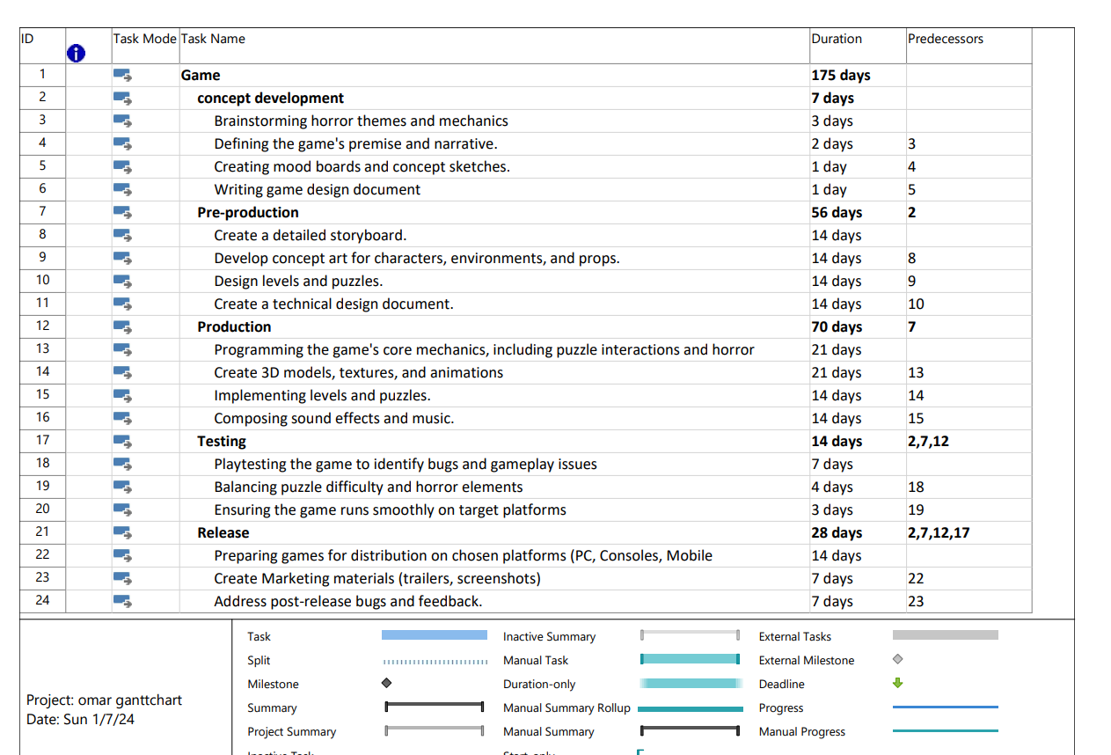

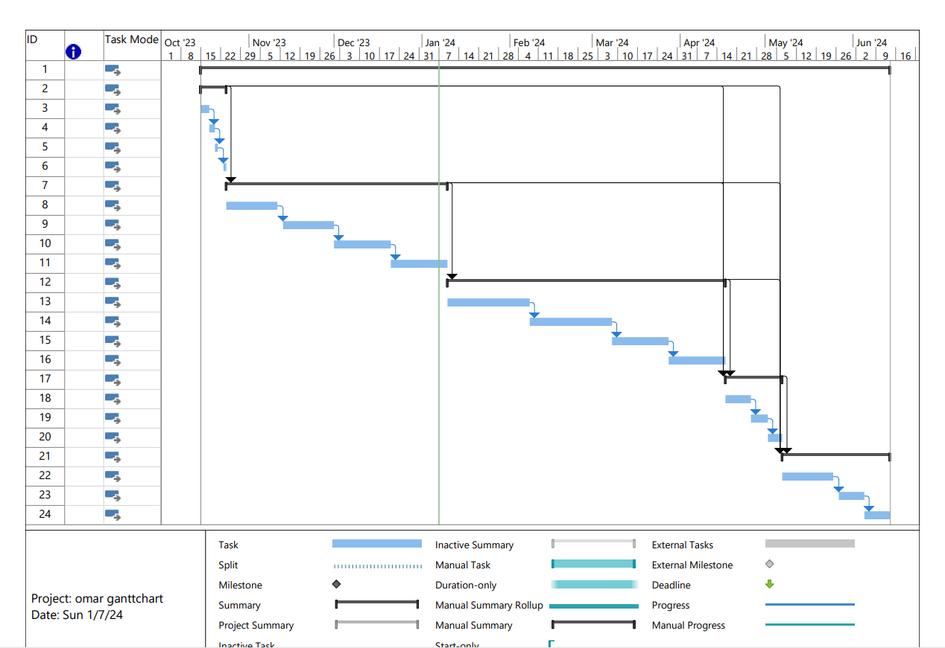

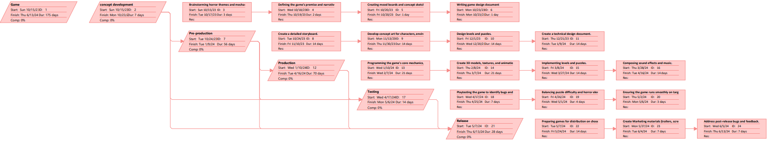

# Chapter 2: Requirements and Analysis



## Software Process Model

Software Process is a coherent set of activities for specifying, designing, implementing, and testing software systems. A software Process Model is an abstract representation of a process that presents a description of a process from some perspective.

Types of Software Process Models: Waterfall Model, V-Model, Incremental Model, Rapid Application Development (RAD) Model, Spiral Model & Agile Model.

In our project, we will choose the agile model exactly Agile Software Development.

The Agile software development model has empowered the development team with the ability to create and respond to change to succeed in an uncertain environment.

Agile software development is one of the big buzzwords of the software development industry which is a unique way of managing software development projects. Rather than a specific software development method, it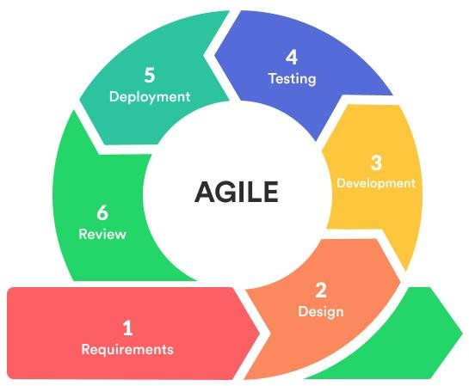 is an umbrella term for a set of methods and practices based on the values and principles expressed in the Agile Manifesto. Solutions evolve through collaboration between self-organizing, cross-functional teams utilizing the appropriate practices for their context as shown in the figure [14].

Why agile in our project?

There are many reasons for using the agile model. Next is the most important of them for use in this project:

We deliver software that is delivered frequently.

Continued attention to technical excellence and superior design.

Regular adaptation to changing circumstances.

Late changes in requirements are welcomed.

## System scope with explanation

**Category:** The project falls under the category of puzzle-based interactive gaming software, aiming to offer an immersive experience that merges intricate puzzle-solving with time-sensitive challenges such as

1-enhancing player’s cognitive skills

2- the ability to make decisions under pressure

3- increase the player’s ability to think fast

4- the ability to control the player’s stress management [15].

**Target Group:** The target audience primarily includes gamers interested in intellectual challenges within an engaging storyline. Additionally, individuals seeking to enhance their problem-solving and decision-making skills under time pressure are also a significant target demographic [16].

**Tools:** The development of "Alone in the Darkness" involves the use of sophisticated software tools and platforms such as Unity or Unreal Engine for game development, Adobe Photoshop or Blender for graphical asset creation, programming languages like C# or C++ for scripting, and audio editing software for sound effects and music, which were mentioned in the part above [17].

**Output:** The project scope aims to deliver several key outputs, including:

Playable Game Prototype: Demonstrating core gameplay mechanics, puzzles, time constraints, and a captivating storyline [18].

**Art Assets:** Visual elements such as characters, environments, animations, and special effects to create an immersive gaming experience [19].

User Interface Design: Intuitive and visually appealing interfaces guiding players through the game effectively [20].

**Game Mechanics Documentation:** Comprehensive documentation detailing the design, implementation, and functionalities of puzzles, time-based challenges, and overall gameplay mechanics.

The outlined project scope encompasses the specific goals, target audience, necessary tools, and anticipated deliverables for "Alone in the Darkness," aligning with the objective of providing an engaging and educational gaming experience that fosters cognitive development and decision-making skills within an adrenaline-inducing, time-constrained environment.

**Project Goals:**

Develop an immersive gaming experience that challenges and enhances players' problem-solving abilities within a time-constrained environment.

Create a compelling narrative-driven game that fosters suspense and engagement while promoting cognitive skill development.

Merge entertainment and education by offering an interactive platform that provides both enjoyment and valuable cognitive benefits.

**Deliverables:**

**Playable Game Prototype:** A functional prototype displaying core gameplay mechanics, including puzzles, time constraints, user interface, and the game's ambiance.

**User Interface Designs:** Designs for an intuitive and visually appealing user interface guiding players through the game effectively.

**Testing Reports and Feedback:** Detailed reports from iterative testing phases, including user feedback and implemented improvements.

**Features and Functions:**

**Puzzle Mechanics:** Diverse and progressively challenging puzzles requiring critical thinking and problem-solving skills.

**Time-Constrained Environment:** Integration of a timer mechanic, adding pressure to solve puzzles within specified time limits.

**Narrative and Atmosphere:** Compelling storyline and immersive ambiance created through audio, visuals, and storytelling elements.

**Intuitive User Interface:** User-friendly interface facilitating smooth navigation without disrupting the suspenseful ambiance.

**Testing and Iteration:** Continuous testing, feedback collection, and iterative improvements to refine gameplay mechanics and difficulty levels.

**Optimization for Platforms:** Ensuring compatibility and performance optimization across various devices and platforms.

**Tasks and Deadlines:**

**Game Design and Conceptualization: [Start - Week 1 to 4]**

**Development of Prototype: [Week 5 to 12]**

**Art Asset Creation: [Week 8 to 16]**

**User Interface Design: [Week 10 to 18]**

**Testing and Iteration Phases: [Week 14 to 22]**

**Optimization and Finalization: [Week 20 to 28]**

**Costs:**

The costs will primarily include:

**Development team salaries and wages**

**Software and hardware expenses**

**Licensing fees for tools and software**

**Marketing and promotional costs**

**Testing and quality assurance expenses**

Overall, the project scope encompasses the development of a captivating game that challenges players' cognitive skills while delivering an entertaining and immersive experience within specified timelines and budgetary constraints.

## Functional Requirements & Non-Functional Requirements

**Functional Requirements:**

* Account Management:

1.The system shall Allow players to create accounts.

* Leaderboards and Interaction:

1.The system shall Display usernames in leaderboards, online interactions, and relevant areas.

* Puzzle Implementation:

1 The system shall Implement various puzzle types

1.1the system shall increase difficulty and complexity.

2. The system shall Ensure puzzles are logically consistent

with clear solutions.

* Player Assistance:

1. The system shall Provide optional hints for struggling

Players.

2. The system shall Implement a visible time countdown.

* Game Mechanics:

1.The system shall Allow players to restart individual

puzzles.

2.The system shall Track player progress through the

game.

2.1 The system shall have checkpoints.

3.The system shall Unlock new areas.

3.1 The system shall unlock a new puzzle.

4.The system shall count Time.

4.1 The system shall Offer optional rewards or

achievements for completing puzzles.

* User Experience:

1.The system shall Provide clear visual cues.

1.1 The system shall provide feedback

2.The system shall Integrate an optional tutorial system to

guide new players.

**Nonfunctional Requirements:**

* Performance:

1. The system shall Maintain smooth frame rates and minimal loading times.

2. The system shall Optimize memory usage.

* Stability and Security:

1. The system shall ensure stability.

1.1 The system shall prevent crashes and bugs.

2. The system shall Store usernames securely alongside other

player data.

* Accessibility and Availability:

1. The system shall Ensure the game is accessible 24/7.

* Post-Launch Support:

1. The system shall Provide post-launch support and

updates.

* User Interface and Settings:

1. The system shall be a user-friendly interface for puzzle

interactions.

2. The system shall Offer adjustable settings.

2.1 The system shall provide audio settings.

2.2 The system shall provide settings for visuals.

2.3 The system shall provide settings for controls.

* Difficulty Levels and Environment:

1. The system shall Design different difficulty levels.

2. The system shall Design the environment to provide

clues and hidden hints.

* Sound Design:

1. The system shall Utilize sound design and music to

create a captivating atmosphere.

* Online Features:

1. The system shall Offer optional online leaderboards or

achievements.

* Testing and Feedback:

1. The system shall Gather feedback from testers to refine

mechanisms and

* Marketing:

1. The admin shall Consider marketing strategies.

2. The admin shall identify the target audience.

## Use Case Diagram with Use Cases descriptions

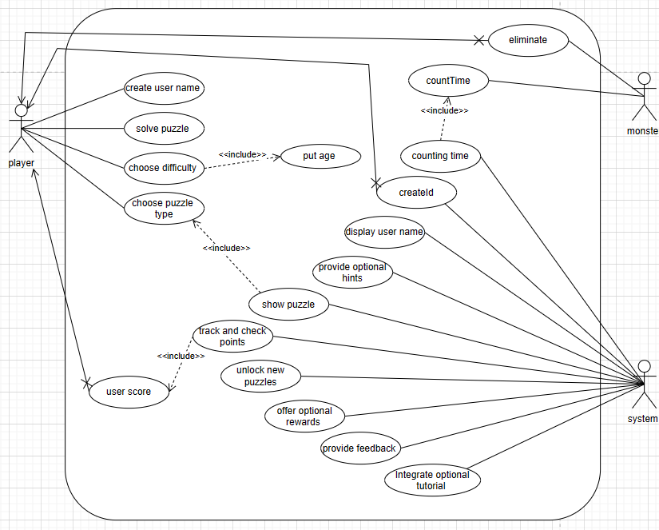

|  |
| --- |
| **Use case name:** create username**.** |
| **Actor:** player. |
| Brief description: The username is the identity of the player in the game. |
| **The basic flow of the event:**  1. The player puts the name.  2. The system shows the name.  3. The system adds the user to the database. |
| **Precondition:** have a different username from the other user. |
| **Postcondition: -.** |
| **Exception flow:** If the player enters a similar name the system displays an error.  message. |

|  |
| --- |
| **Use case name:** choose puzzle type. |
| **Actor:** player. |
| **Brief description:** The player chooses the type of puzzle (math’s, coding, test) |
| **The basic flow of the event:**  1. The system shows the list of the puzzle types.  2. The player selects one of them. |
| **Precondition:** -. |
| **Postcondition:** -. |
| **Exception flow:** -. |

|  |
| --- |
| **Use case name:** unlock new puzzles. |
| **Actor:** system. |
| **Brief description: A** new puzzle is unlocked when the player finishes the current puzzle. |
| **The basic flow of the event:**  1. the player finished the current puzzle.  2. new puzzles are unlocked. |
| **Precondition:** the player finishes the current level. |
| **Postcondition:** -. |
| **Exception flow:** -. |

|  |
| --- |
| **Use case name:** provide optional hints. |
| **Actor:** system. |
| **Brief description:** the system provides a hint if the player wants. |
| **The basic flow of the event:**  1. after two minutes of playing the system shows a message.  2. the player chooses yes or no.  3. if you choose yes, the system shows a hint. |
| **Precondition:** two minutes pass of time. (count time) |
| **Postcondition: -.** |
| **Exception flow:** If the player chooses to the system does not show a hint. |

|  |
| --- |
| **Use case name:** track and checkpoints. |
| **Actor:** system. |
| **Brief description:** when the score increases the system increases the point of the player. |
| **The basic flow of the event:**  1. the score increases.  2. the point increase. |
| **Precondition:** the player has a score. |
| **Postcondition:** -. |
| **Exception flow:** the user does not have any score, so the user does not have points**.** |

|  |
| --- |
| **Use case name:** showpuzzle. |
| **Actor:** system. |
| **Brief description:** the player chooses a puzzle and unlocks a previous puzzle then the system is shown. |
| **The basic flow of the event:**  1. the player chooses a puzzle type.  2. the system shows a puzzle.  3. the player finishes the current puzzle.  4. the system shows another puzzle. |
| **Precondition:** the player chooses a puzzle and unlocks a previous puzzle. |
| **Postcondition:** -. |
| **Exception flow:** -. |

|  |
| --- |
| **Use case name:** choose difficulty. |
| **Actor:** player. |
| **Brief description: The player chooses the difficulty of the level they want to start from after entering the age of one.** |
| **The basic flow of the event:**  1. The system shows the list of difficulty levels.  2. The player selects one of them. |
| **Precondition:** the player puts the age. |
| **Postcondition:** -. |
| **Exception flow:** the player puts an invalid age the system sends an error message. |

## Activity Diagram

Activity diagram is basically a flowchart to represent the flow from one activity to another activity. The activity can be described as an operation of the system. The control flow is drawn from one operation to another.

# Chapter 3: Design



## Sequence Diagrams

A sequence diagram is a type of interaction diagram because it describes how—and in what order—a group of objects works together. These diagrams are used by software developers and business professionals to understand requirements for a new system or to document an existing process.

## Class Diagram

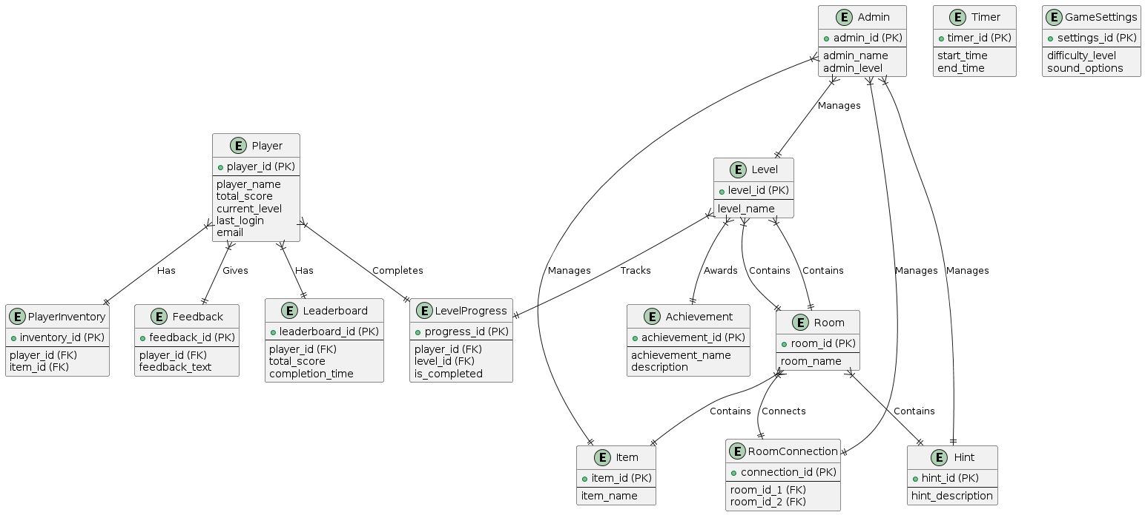

## Database ER Diagram

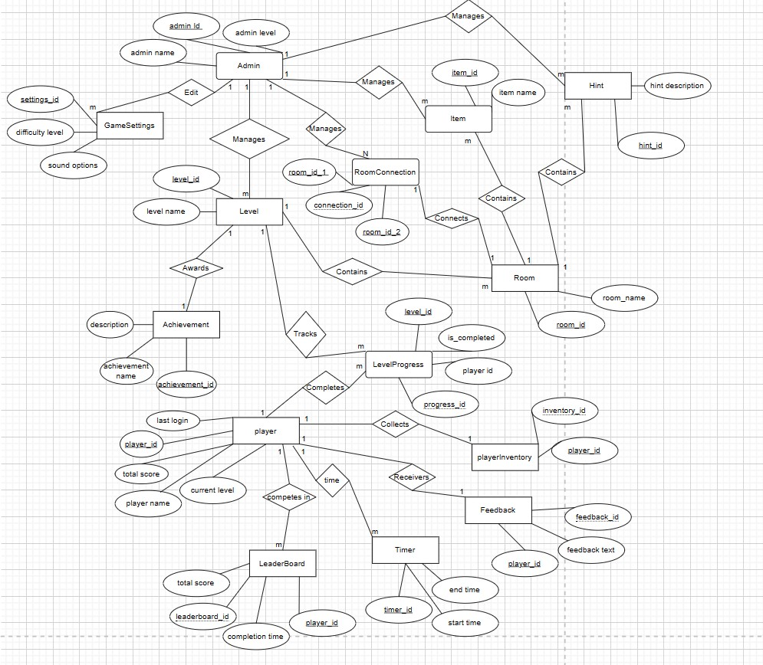

# Chapter 4: System Implementation



## Main System Screenshots

Show screenshots of your system.

## Important code fragments

Show important codes of your implemented system.

## List of Non-Implemented requirements and reasons

List of not implemented requirements and explain reasons.

# Chapter 5: System Evaluation



## System Testing

The purpose of this test is to evaluate the system's compliance with the specified requirements. Test Cases Using Black Box Testing methods.

## System Evaluation

System evaluation is the process of assessing the performance of a complete system to discover how it is likely to perform in live market conditions. It may include evaluation tables and graphs.

# Chapter 6: Conclusion & Future Work

It should drive the reader to see that you accomplish your objectives, and you should state any further work recommendations.



## Conclusion

* + 1. In conclusion, the "Alone in the Darkness" project successfully achieved its primary objective of creating an engaging and challenging game that captivates players with its immersive levels and intricate gameplay mechanics. By employing Unity for development, we were able to leverage powerful tools and assets that enhanced the overall gaming experience. Our implementation of locked and unlocked levels based on player progress has not only added depth to the gameplay but also encouraged continuous engagement and replayability.

### Throughout the development process, we encountered and overcame several challenges, ranging from technical hurdles in coding and design to ensuring seamless integration of all game components. These challenges provided us with valuable learning experiences, enhancing our problem-solving skills and technical proficiency. The collaboration among team members, coupled with the guidance of our supervisor, Dr. Ayham Alomari, was instrumental in the project's success.

### Overall, "Alone in the Darkness" stands as a testament to our collective effort, creativity, and technical abilities. The project has laid a solid foundation for future developments and has given us the confidence to tackle more complex game development endeavors in the future.

## Future work

Looking ahead, there are several areas where "Alone in the Darkness" can be further enhanced and expanded. Future work on this project could include the following:

Additional Levels and Content: Developing new levels with unique challenges and storylines to keep the game fresh and engaging for returning players. Expanding the game's content can also include new characters, power-ups, and hidden easter eggs.

Multiplayer Mode: Introducing a multiplayer mode where players can collaborate or compete. This can significantly increase the game's appeal and provide a different dimension to the gameplay experience.

Enhanced Graphics and Sound: Improving the game's graphics and sound effects to provide a more immersive experience. Utilizing advanced rendering techniques and high-quality audio can make the game more visually and aurally appealing.

Mobile Platform Support: Adapting the game for mobile platforms to reach a broader audience. This involves optimizing the game's controls and performance for mobile devices.

AI and Machine Learning: Incorporating AI and machine learning to create more adaptive and intelligent NPCs (non-player characters) that can provide a more challenging and dynamic gameplay experience.

Community and Player Feedback: Continuously engaging with the player community to gather feedback and make iterative improvements based on their suggestions and experiences. This can help in fine-tuning the game and ensuring it meets the expectations of its audience.

By focusing on these areas, "Alone in the Darkness" can evolve into a more comprehensive and captivating game, offering a richer experience to its players and maintaining its relevance in the competitive gaming market.

# References

Cite sources you used in your report.

# Appendix

Any additional information or data that supports or extends the main document or report.